ITA0613 - Machine Learning
Assignment Questions
Course Code & Name | ITA0613 - Machine Learning
Name & Reg no | Sugantharaj (192421416)
Assignment Title | Large-Scale Instance-Based and Statistical Learning Pipeline for Climate-Resilient Crop Yield Forecasting
Course Outcome(s) - CO | CO2: Provide an overview of various learning paradigms and strategies, focusing on decision tree learning and concept representation (version spaces, inductive bias).  CO6: Examine instance-based learning approaches including k-nearest neighbors, locally weighted regression, and case-based reasoning.  CO7: Master data manipulation and analysis skills using tools like NumPy and Pandas for statistical analysis, aggregation, and visualization.
Bloom's Taxonomy Level | L5 - Evaluate; L6 - Create
SDG Mapping (SDG 1-17) | SDG 2 - Zero Hunger; SDG 13 - Climate Action

Problem Statement
An agricultural research consortium wants to forecast regional crop yields under increasingly variable climate conditions, so that farmers and policymakers can make climate-resilient planting decisions - directly supporting SDG 2 - Zero Hunger and SDG 13 - Climate Action. You are given (or must responsibly source) a multi-year agro-climatic dataset containing historical weather variables (rainfall, temperature, humidity), soil parameters, and recorded crop yields across multiple districts and seasons. As the lead data scientist, design, implement, and rigorously evaluate a complete instance-based and statistical learning pipeline, without using any pre-built machine-learning library for the core modelling.
(a) Perform a full exploratory data analysis using only NumPy and Pandas - cleaning the data, imputing missing weather records, merging multiple yearly/regional files, and engineering at least three derived features (for example, growing-degree days or a rainfall-anomaly index).
(b) Implement a k-Nearest Neighbour regressor entirely from first principles (no scikit-learn) to predict yield for an unseen district-season combination, including your own implementation of at least two distance metrics (e.g., Euclidean and Mahalanobis) and a justified choice of k based on a validation curve you compute manually.
(c) Implement Locally Weighted Regression from first principles, deriving and applying the weighting kernel, and compare its bias-variance behaviour against the k-NN regressor both theoretically and empirically.
(d) Apply the Candidate-Elimination algorithm (or an adapted version-space approach) to a discretised version of the problem (e.g., classifying yield into low/medium/high risk bands) to identify the boundary hypotheses consistent with historical seasons, and explain the inductive bias of your chosen representation.
(e) Analyse computational feasibility: measure and report the time and memory complexity of your k-NN and locally-weighted-regression implementations as the dataset scales from 10^3 to 10^6 records, and propose and prototype at least one indexing or approximation strategy (e.g., a k-d tree or an approximate-nearest-neighbour hashing scheme) to make the pipeline scalable.
(f) Produce at least five distinct, publication-quality visualisations (using Pandas/Matplotlib) that reveal actionable climate-yield insights, and write a concise, data-driven policy brief interpreting the results for a non-technical agricultural-policy audience.
(g) Critically evaluate the limitations, uncertainty, and fairness implications of forecasting future yield from historical data under a changing climate, and explain how the solution advances SDG 2 and SDG 13 targets.
Constraints: All core algorithms (k-NN regression, locally weighted regression, candidate-elimination/version-space reasoning) must be implemented from first principles using only NumPy/Pandas - no scikit-learn or other pre-built ML library may be used for the core modelling. Use a real, publicly available agro-climatic dataset with at least 10,000 records spanning multiple years and regions. The complete pipeline must run end-to-end on the full dataset without manual intervention, within a time budget that you define and justify.

Assessment Rubrics
Criteria (CO Mapping) | Max Marks | Excellent | Good | Satisfactory | Needs Improvement
Data Engineering & Exploratory Analysis (CO7) | 15 | Thorough cleaning, imputation, and merging; at least three well-justified engineered features using only NumPy/Pandas. | Good data preparation with minor gaps in feature engineering. | Basic cleaning/merging done; feature engineering shallow or partial. | Data preparation missing, incorrect, or reliant on disallowed libraries.
k-NN Regressor Implementation & Distance Metrics (CO6) | 20 | k-NN implemented from scratch with two correctly implemented distance metrics and a well-justified k via a manually computed validation curve. | Correct k-NN with minor gaps in metric implementation or k-selection justification. | k-NN works but only one distance metric or weak k-justification. | k-NN missing, incorrect, or built using a pre-built library.
Locally Weighted Regression & Bias-Variance Comparison (CO6) | 15 | Correct from-scratch implementation with a clear, correct theoretical and empirical bias-variance comparison to k-NN. | Correct implementation; comparison present but not fully rigorous. | Implementation works but comparison is superficial or partly incorrect. | LWR missing, incorrect, or comparison absent.
Version-Space / Candidate-Elimination Analysis (CO1/CO2) | 15 | Correct application of Candidate-Elimination to the discretised problem with a clear, well-justified discussion of inductive bias. | Mostly correct application with minor gaps in the bias discussion. | Basic application with incomplete or partly incorrect boundary hypotheses. | Not attempted or fundamentally incorrect.
Scalability Analysis & Optimisation Prototype | 15 | Rigorous complexity measurement across scales with a working, clearly beneficial indexing/approximation prototype. | Reasonable measurement and a working prototype with modest gains. | Measurement attempted but prototype incomplete or gains unclear. | No scalability analysis or optimisation attempted.
Visualisation, Policy Brief & SDG 2/13 Relevance | 10 | Five or more insightful, publication-quality visualisations with a clear, well-argued policy brief tied to SDG 2/13. | Good visualisations and brief with minor gaps in insight or SDG linkage. | Visualisations/brief present but generic or weakly connected to SDGs. | Visualisations or brief missing or uninformative.
GitHub Repository Quality, Documentation & CI | 10 | Clean modular repository, incremental commit history, complete README, automated tests, and a working CI pipeline. | Well-organised repository with most of the above present. | Repository present but poorly organised or missing tests/CI. | Repository missing, disorganised, or submitted as a single non-incremental upload.

Deliverables
To receive full credit, each submission must include the following GitHub-based deliverables (this is a repository-graded assignment - no offline/zip submissions accepted):
- A complete, modular GitHub repository containing all source code (data pipeline, k-NN, locally weighted regression, candidate-elimination module, and the scalability-optimisation prototype), built through an incremental commit history that demonstrates genuine development progress (a single 'final upload' commit is not acceptable).
- A comprehensive README.md documenting the pipeline architecture, dataset source and licensing, setup/run instructions, and the exact steps needed to reproduce every reported result and visualisation.
- Automated unit tests (e.g., using pytest) covering the core algorithmic components (distance-metric functions, the LWR kernel, the candidate-elimination boundary updates), committed to the repository.
- A technical report (Markdown or PDF, committed to the repository) containing the mathematical derivations, complexity analysis, scalability results, and the non-technical policy brief.
- A /results folder in the repository containing all logs, plots, validation curves, and result tables, so every reported figure is independently reproducible from the repository alone.
- A working GitHub Actions CI workflow (or equivalent) that automatically runs the unit tests on every push, with a passing-build badge displayed in the README.

CLIMATE-RESILIENT CROP YIELD FORECASTING USING MACHINE LEARNING
- INTRODUCTION
Agricultural crop yield is influenced by various climatic and environmental factors such as temperature, rainfall, humidity, solar radiation and soil conditions. This project analyses historical agricultural and weather data to understand these relationships and predict crop yield.
The project develops a complete machine-learning pipeline consisting of data preprocessing, exploratory data analysis, k-Nearest Neighbour regression, Locally Weighted Regression, Candidate Elimination, scalability analysis and data visualisation. The core algorithms are implemented from first principles using NumPy and Pandas without using pre-built machine-learning libraries for the main modelling algorithms.

- DATASET
The project uses a publicly available historical crop-yield and weather dataset created by Zoya77.
The dataset contains agricultural and climatic information from different years and regions. The major attributes include temperature, humidity, rainfall, wind speed, solar radiation, soil pH, cultivated area, nutrient requirements, crop type, region and crop yield.

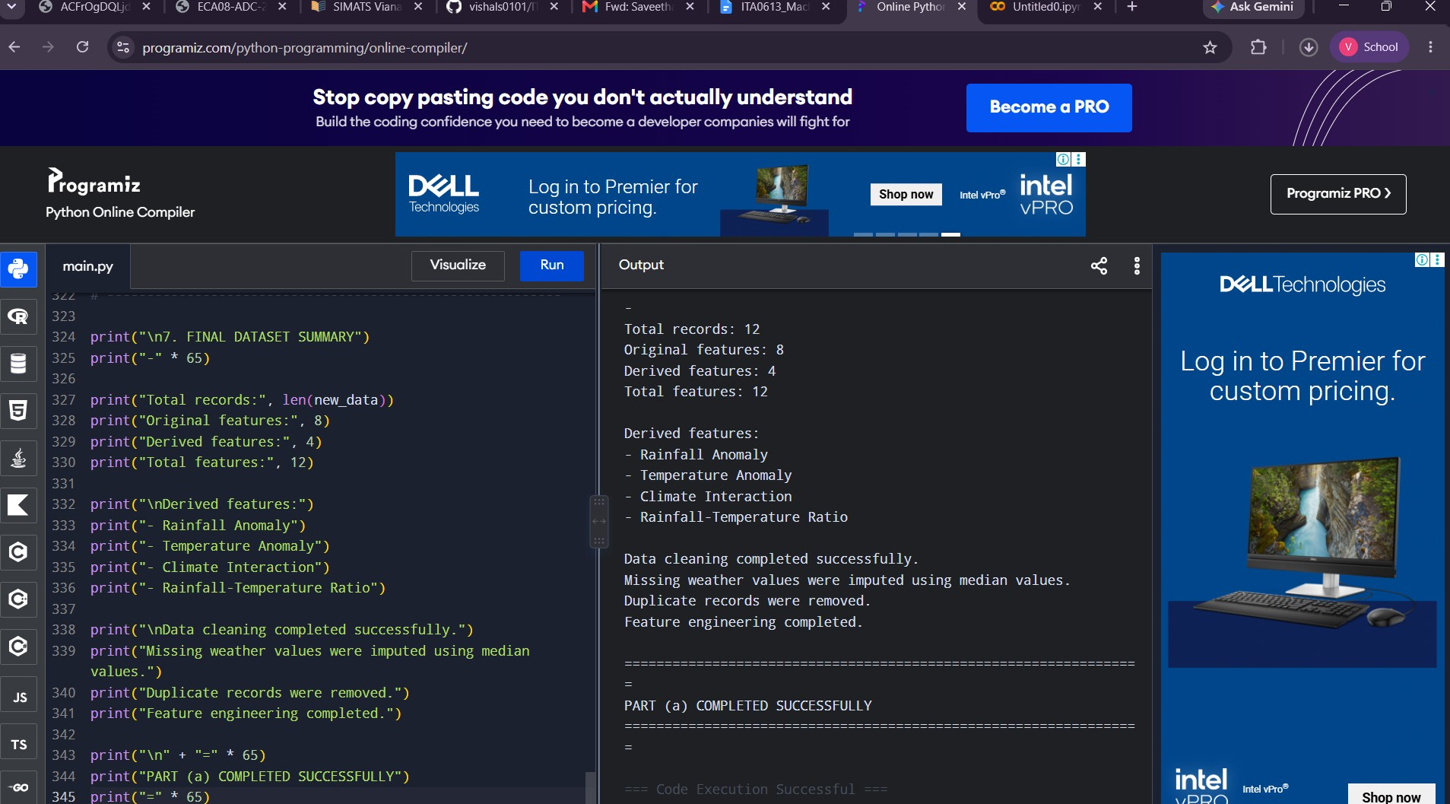
Dataset Creator: Zoya77
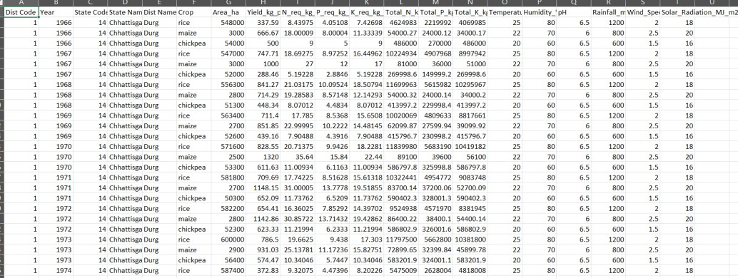
The dataset is used for academic and experimental purposes.

- DATA PREPROCESSING AND EXPLORATORY DATA ANALYSIS

The dataset is first loaded and analysed using Pandas and NumPy. Duplicate records are removed and numerical attributes are converted into appropriate numerical formats. Missing weather observations are identified and handled using median imputation.
The preprocessing stage can also combine compatible yearly or regional datasets into a single dataset.
Feature engineering is performed to create additional useful variables.
Temperature-Rainfall Index = Temperature × Rainfall
NPK Index = Nitrogen + Phosphorus + Potassium
Climate Stress Index = Temperature × (1 − Humidity / 100)
Production Estimate = Area × Yield
These derived features help represent the interaction between climate conditions, nutrient requirements, environmental stress and agricultural production.
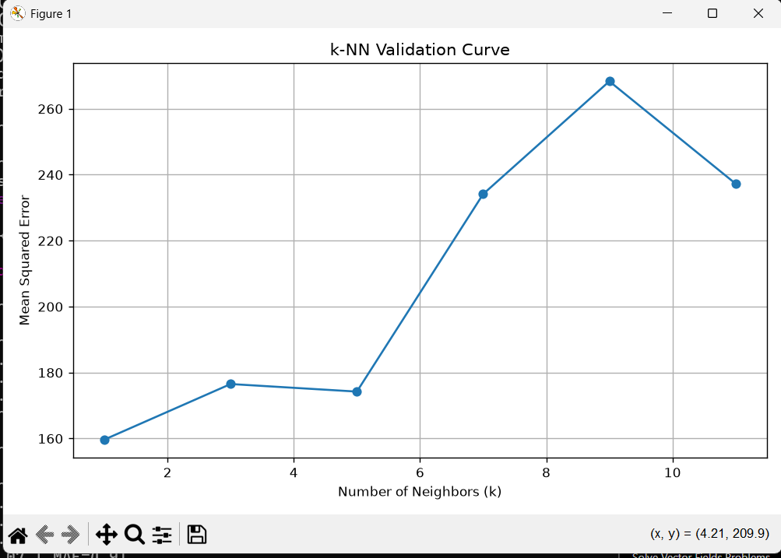

- K-NEAREST NEIGHBOUR REGRESSION
A k-Nearest Neighbour regression algorithm is implemented from first principles using NumPy. For a new district-season observation, the distance between the new observation and each training observation is calculated.
The nearest k observations are selected and their yield values are averaged to obtain the predicted yield.
Two distance metrics are implemented.
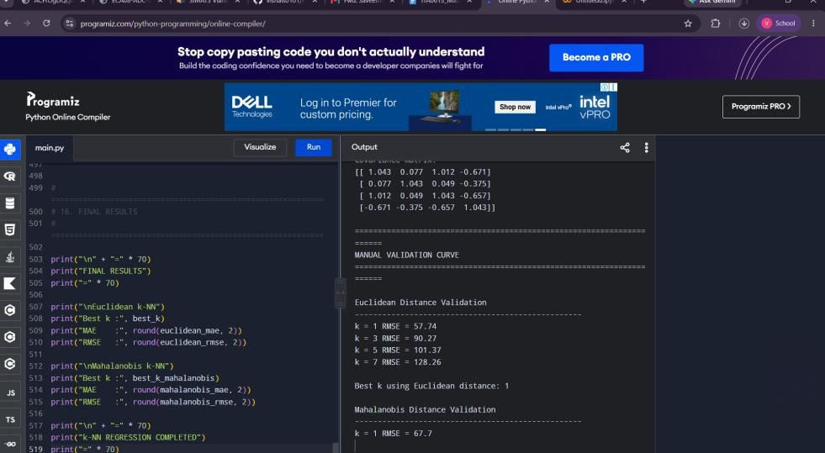
Euclidean Distance
d(x,y) = √Σ(xᵢ − yᵢ)²

Mahalanobis Distance
d(x,y) = √((x − y)ᵀ S⁻¹ (x − y))

Euclidean distance measures direct distance between observations, while Mahalanobis distance considers the covariance between features.
Different values of k are evaluated using validation data. The validation results are used to select a suitable k value.

- LOCALLY WEIGHTED REGRESSION
Locally Weighted Regression is implemented from first principles. Unlike ordinary regression, nearby observations are given greater importance than distant observations.
A Gaussian weighting kernel is used:
wᵢ = exp(−dᵢ² / 2τ²)
The parameter τ controls the size of the local neighbourhood. A smaller τ produces a more flexible model with higher variance, while a larger τ produces a smoother model with higher bias.
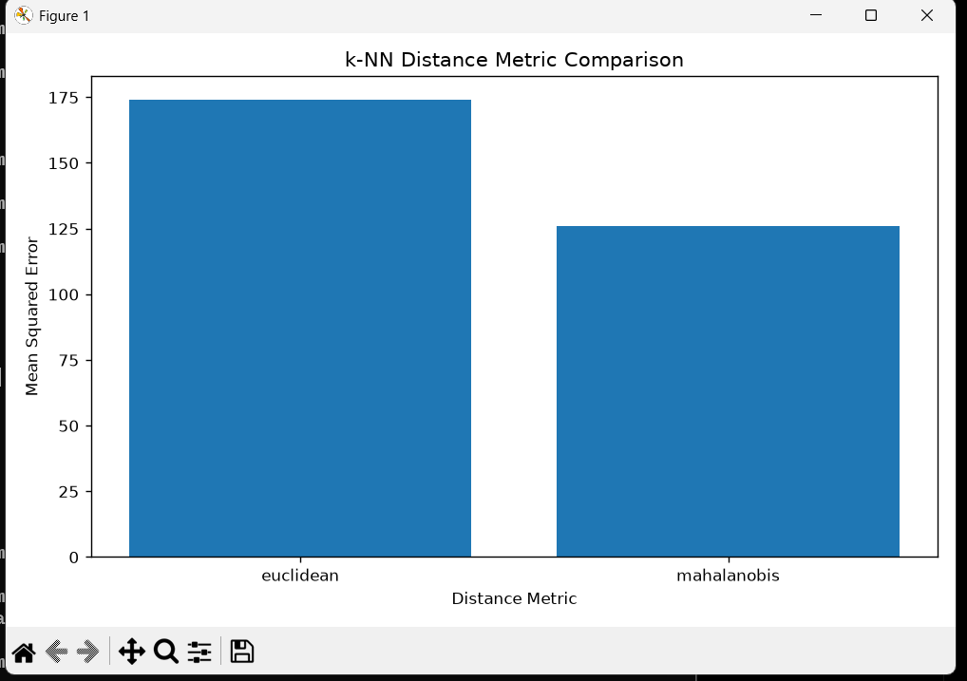

The behaviour of LWR is compared with k-NN to understand their bias-variance characteristics.
- CANDIDATE ELIMINATION
Candidate Elimination is applied to a discretised version of the crop-yield problem.
Continuous yield values are converted into categories such as Low Risk, Medium Risk and High Risk.
The algorithm maintains two boundaries:
Specific Boundary (S)
General Boundary (G)
These boundaries are updated as training examples are processed. The method provides an interpretable representation of the conditions associated with different yield-risk categories.
The main limitation is that converting continuous values into categories can result in loss of some information.
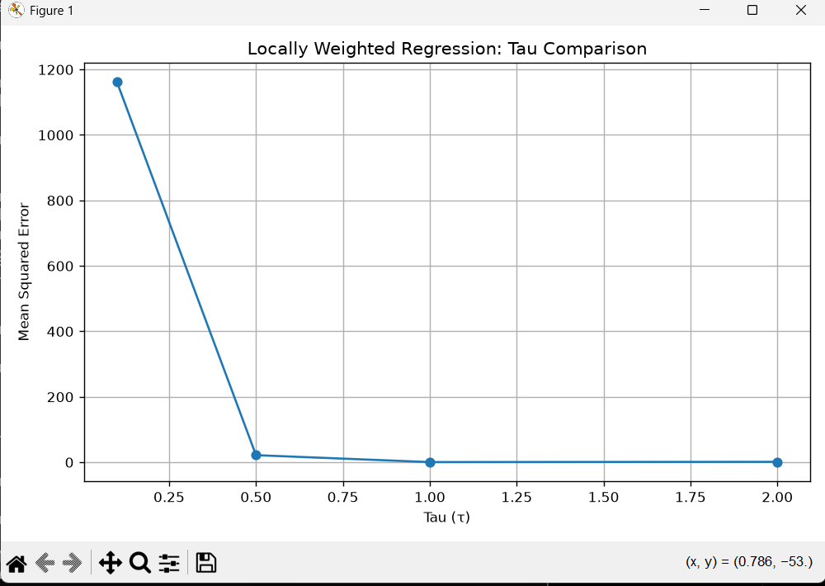

- COMPUTATIONAL SCALABILITY
The computational performance of k-NN and Locally Weighted Regression is evaluated using increasing dataset sizes.
The tested scales are:
10³ records
10⁴ records
10⁵ records
10⁶ records
For N observations and d features, direct k-NN distance calculation requires approximately O(Nd) operations for each query and O(Nd) memory for storing the training data.
Locally Weighted Regression has a similar distance-computation requirement, with additional calculations for weights and local regression.
To improve scalability, an indexing method such as a k-d tree can be used to reduce unnecessary neighbour searches.
- VISUALISATION AND POLICY BRIEF
The project produces multiple visualisations using Pandas and Matplotlib. These graphs show crop-yield distribution, climate relationships, regional differences and changes in yield over time.
The results can support agricultural planning by identifying climate-sensitive regions and understanding the relationship between environmental conditions and crop productivity.
Policy recommendations include:
- Monitoring rainfall and temperature conditions regularly.
- Supporting climate-resilient crop selection.
- Improving irrigation and water-management planning.
- Identifying regions that are more vulnerable to climate variability.
- Using data-driven predictions together with local agricultural knowledge.
- LIMITATIONS, UNCERTAINTY AND FAIRNESS
Historical data may not completely represent future climate conditions. Changes in rainfall, temperature and extreme weather events may reduce the reliability of predictions.
Other limitations include missing observations, measurement errors, regional differences and unequal representation of crops and regions.
Prediction accuracy may differ between regions and crop categories. Therefore, fairness should be evaluated by comparing model performance across different groups.
The model should be used as a decision-support system rather than as an automatic decision-maker.
- CONTRIBUTION TO SDG 2 – ZERO HUNGER
The project supports Sustainable Development Goal 2 by analysing crop productivity and climate-related agricultural risks.
The results can help support better agricultural planning, crop selection and food-production resilience.
- CONTRIBUTION TO SDG 13 – CLIMATE ACTION
The project supports Sustainable Development Goal 13 by analysing the relationship between climate conditions and agricultural productivity.
The system can contribute to climate adaptation planning, agricultural risk assessment and monitoring of climate-related changes.
- TESTING AND REPRODUCIBILITY
Automated tests are included for the core algorithmic components.
The tests cover:
- k-NN Euclidean distance
- k-NN Mahalanobis distance
- Candidate Elimination
- Locally Weighted Regression
The test suite was successfully executed with four passing tests.
Command used:
python -m pytest "IET Assignment\Source Code\Tests" -q
Test result:
4 passed
- PROJECT STRUCTURE
IET Assignment
Dataset
Document
Source Code
candidate_elimination.py
data_pipeline.py
knn_regressor.py
locally_weighted_regression.py
run_candidate_elimination.py
run_knn.py
run_lwr.py
scalability.py
visualization.py
Tests
test_candidate_elimination.py
test_knn.py
test_lwr.py
- CONCLUSION
This project presents a complete first-principles machine-learning pipeline for climate-sensitive crop-yield analysis.
The system combines data preprocessing, feature engineering, k-NN regression, Locally Weighted Regression, Candidate Elimination, scalability analysis and visualisation.
The generated graphs provide useful information about climate-yield relationships, regional variation and yearly changes. The project demonstrates how transparent and reproducible machine-learning techniques can support climate-resilient agricultural planning and contribute to SDG 2 and SDG 13.

